"Arunachal & Meghalaya – Peaks, Monasteries & Waterfalls”
(6N/7D)

Discover the breathtaking beauty of Arunachal Pradesh and Meghalaya on this unforgettable 7 Days / 6 Nights journey through the Eastern Himalayas. Travel through the scenic hill towns of Dirang, Tawang, Bomdila, Shillong, and Cherrapunji, each offering spectacular landscapes and unique cultural experiences.

Witness the majestic Sela Pass, explore the iconic Tawang Monastery, and pay tribute to the historic Jaswant Garh War Memorial. Experience the tranquil charm of Madhuri Lake and the panoramic mountain views that make Arunachal truly unforgettable. Continuing to the charming city of Shillong and the breathtaking landscapes of Cherrapunji, famous for its waterfalls, caves, and mist-covered valleys. Perfect for nature lovers, adventure seekers, families, and couples, this itinerary offers the perfect blend of scenic beauty, spirituality, and Himalayan adventure, creating memories that last a lifetime.
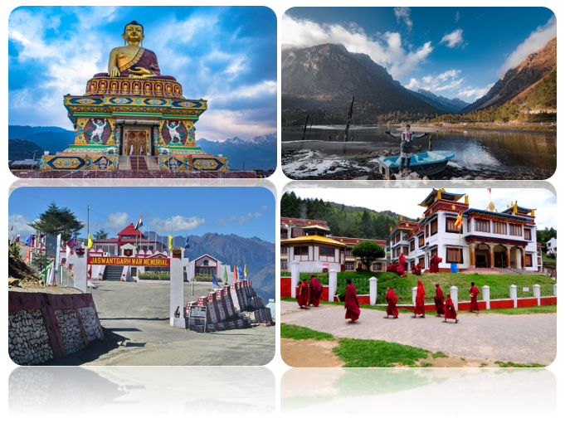
We wish you a happy, safe and unforgettable journey with us
Detailed Itinerary
Day 1: Arrive in Guwahati – Transfer to Dirang (293 Km | 8 Hrs approx.)
Upon arrival at Lokpriya Gopinath Bordoloi International Airport or Guwahati Railway Station, meet our representative and begin your scenic drive to Dirang, a picturesque hill town in Arunachal Pradesh. En route, enjoy breathtaking views of lush green valleys, mountain streams, and charming villages. Upon arrival, check in to your hotel and relax amidst the serene Himalayan surroundings. Overnight stay in Dirang.
Day 2: Dirang – Tawang (132 Km | 4 Hrs approx.)
After breakfast, check out and drive towards Tawang, one of Arunachal Pradesh's most beautiful destinations. En route, cross the spectacular Sela Pass (13,700 ft), renowned for its snow-covered landscapes and the picturesque Sela Lake. Visit the historic Jaswant Garh War Memorial, dedicated to the brave soldier Jaswant Singh Rawat. Continue your journey through breathtaking mountain scenery before arriving in Tawang. Check in to your hotel for an overnight stay in Tawang.
Day 3: Tawang Sightseeing
After breakfast, enjoy a full-day sightseeing tour of Tawang. Visit the magnificent Tawang Monastery, the largest monastery in India, followed by the Tawang War Memorial, dedicated to the heroes of the 1962 Indo-China War. Explore the peaceful Madhuri Lake (Sangetsar Lake) and the scenic PT Tso Lake (subject to weather and permits). Return to the hotel in the evening for an overnight stay in Tawang.
Day 4: Tawang – Bomdila (180 Km | 7 Hrs approx.)
After breakfast, check out and drive to the charming town of Bomdila, offering panoramic views of the Eastern Himalayas. Enjoy the scenic journey through mountain passes, waterfalls, and lush forests. Upon arrival, visit the famous Bomdila Monastery and explore the local market if time permits. Check into your hotel for an overnight stay in Bomdila.
Day 5: Bomdila – Guwahati (256 Km | 7 Hrs approx.)
After breakfast, check out from the hotel and drive back to Guwahati, passing through beautiful valleys, tea gardens, and picturesque countryside. Upon arrival, check in to your hotel and spend the evening at leisure. You may explore the local markets or relax after the long drive. Overnight stay in Guwahati.
Day 6: Guwahati – Shillong (99 Km | 3 Hrs approx.)
After breakfast, proceed to Shillong, the charming capital of Meghalaya, popularly known as the "Scotland of the East." En route, stop at the picturesque Umiam Lake, one of the most beautiful lakes in Northeast India. Upon arrival, check in to your hotel and visit popular attractions such as Shillong Peak, Elephant Falls, and Ward's Lake (subject to time). Spend the evening exploring the lively Police Bazaar. Overnight stay in Shillong.
Day 7: Shillong – Cherrapunji – Guwahati Departure (199 Km | 6 Hrs approx.)
After an early breakfast, proceed for an excursion to Cherrapunji (Sohra), famous for its breathtaking waterfalls, limestone caves, and lush green valleys. Visit popular attractions including Nohkalikai Falls, Mawsmai Cave, Seven Sisters Falls, and Eco Park (subject to time). Later, drive back to Guwahati and transfer to Lokpriya Gopinath Bordoloi International Airport or Guwahati Railway Station for your onward journey, carrying unforgettable memories of the majestic Himalayas, ancient monasteries, scenic landscapes, and the natural beauty of Northeast India.
Tour ends with unforgettable memories

HOTELS DETAILS:
Destination/Nights | 3* Hotel Name
Dirang / 01N
Tawang / 02N
Bomdila / 01N
Guwahati / 01N
Shillong / 01N

Package Cost:

3★ Hotels: Rs. per person (Based on 6 guests – Double Sharing Basis)

Inclusion: -
- Breakfast Included.
- 0 DBL Room on sharing based.
- 06 Nights in Accommodation in hotel.
- Assistance on Arrival.
- All Transfers and S.S tours by AC Vehicle.
Exclusions: -
- 5% GST.
- Flight Tickets are not included.
- Guide.
- Extra meal not included or as per the inclusions given above.
- No extra pickup or drop included for lunch/sightseeing unless otherwise mentioned in the itinerary.

